Art. No. 1009950 – OptiVend Touch 11s Touch

Semi-automatic beverage dispenser for the preparation of hot drinks or soup. Execution with one ingredient container for instant products and one mixer motor. Easy to swipe 7” touchscreen with intuitive user-interface. LED light at the outlet for easy cup placement.. Separate hot water output. 24 easily programmable beverages. Drink options are easily set and changed. Intelligent Energy Save Mode (ESM). Strength control (also for milk and sugar). Adjustable mixer speed for the perfect in cup quality.

User-friendly on-screen support., consumption registration and descale indicator. Easy and hygienic cleaning at minimum downtime, without the need to open the machine. Heating element, including dry-boil protection, 3275W. The stainless steel boiler with content of 2.7 ltr., temperature can be set at 70°C up to 97°C. MDB compatible for payment systems and telemetry. OptiVend Touch is user-friendly in every sense. It’s easy to install, operate and maintain. The design combines a stainless steel interior with black casing. The front panel comes in green, white, or black.

Technical specifications:
Dimensions (w x d x h) : 248x501x569 mm.
Max. tap height : : 118 mm
Hour capacity : approx. 320 cups (120 ml)
Dosing time : approx. 11 sec. per cup (120 ml)
Hour capacity hot water : approx. 40 ltr.
Content ingredient container : 5,1 ltr.
Boiler : Stainless steel, 2,7 ltr.
Power supply : 220-240V / 50-60Hz / 3275W
Water connection : 3/4 ” fixed water connection
Art. No. : 1009950 (OptiVend 11s Touch)
Colours: : Black, green, white
Gross Price per piece : €

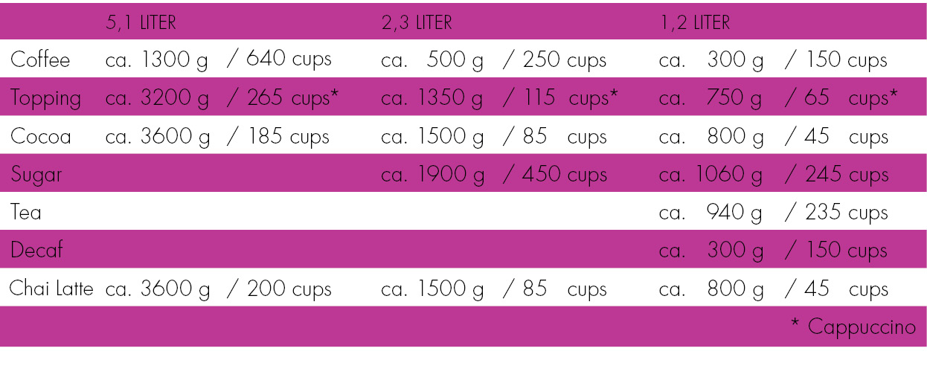
Options and accessories:
+ Cup dispenser
+ Compatible with many payment systems (MDB)
+ Cup detection
+ Immersion pump
+ Base cabinet
+ Company logo on door
+ Other capacities on request

