Art. No. 1007042 - OptiMe 12

OptiMe
Just my type.

Perfect coffee starts with the perfect machine. But when the machine also matches your taste, that’s when the magic happens. Get it all with our newest professional coffee machine: Animo OptiMe®. A strong espresso, a delicious brew, a cappuccino made with fresh milk? OptiMe is developed to bring flavour and appearance: instantly ground coffee, in a personalised design.

OptiMe combines the proven Animo-quality with award-winning design aesthetics in a compact machine that can be customised to match any style. With a recommended daily output of up to 125 cups a day, Animo’s OptiMe impresses with great performance and exceptional taste. The compact machine is fully customisable, and allows small and medium sized businesses to express their individual style.

OptiMe is designed for small and medium sized businesses that want to add their personal style to the coffee corner. The machine can be customised through various materials, colours, and add-ons, and it offers extensive options for the side and back panels, OptiLight LED lighting, background and (commercial) messaging on screen – even during the brewing process. Explore the possibilities with the dedicated online configurator.

What is better than a strong cappuccino with real fresh milk? It's now just one touch away. OptiMe can be equipped with a fresh milk module with an innovative and reliable milk pump for many varieties of espresso-based drinks, including cappuccino, latte and latte macchiato. It’s silent in use and delivers strong milk foam in a matter of seconds.

OptiMe can be ordered as a stand-alone machine, but it is also possible to add a matching milk cooler and/or cup warmer module to complete the look. It’s easy-to-use and intuitive interface makes it the perfect machine for self-service locations.
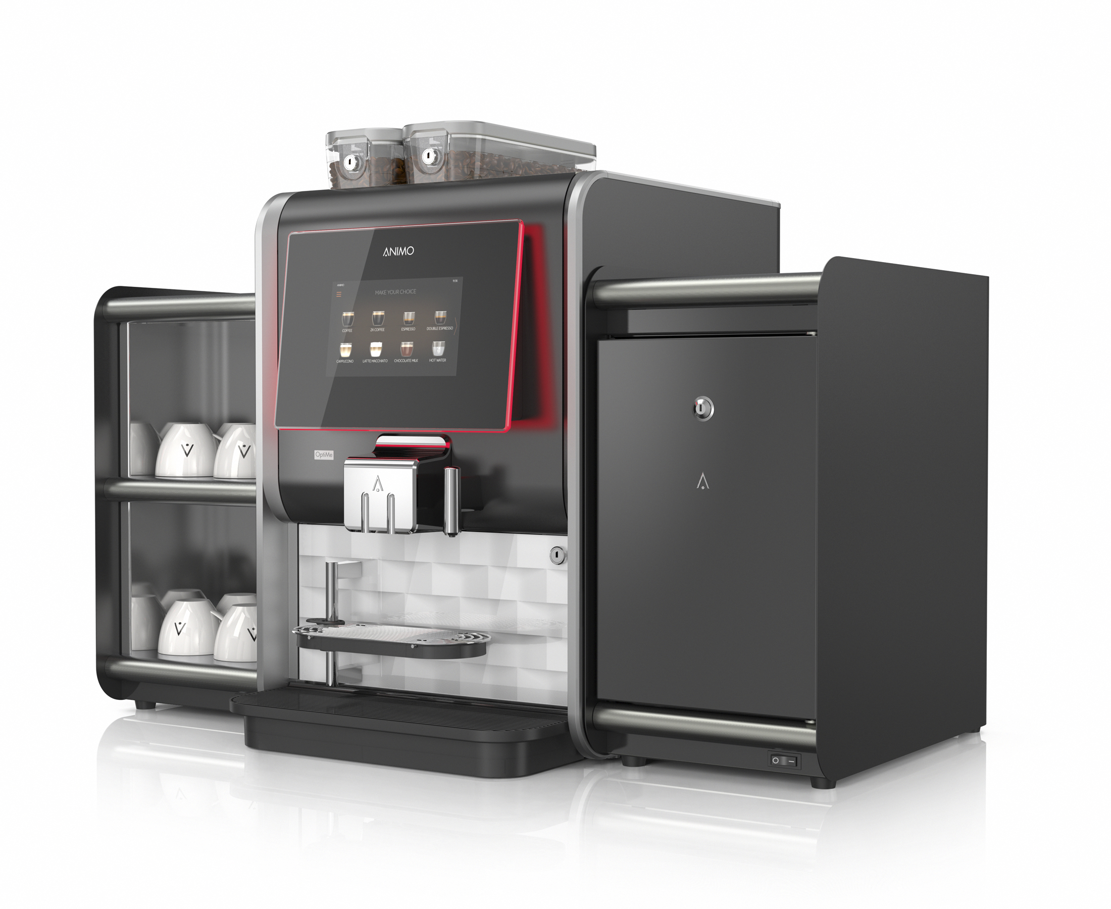
Small machine big flavour:
+ Real coffee, freshly ground
+ Compact 360° design (fully customisable)
+ Add-on: fresh milk module
+ Expandable with matching milk cooler and / or cup warmer
+ Choose one or two bean canisters / grinders
+ User-friendly and designed for minimum maintenance
+ Intelligent Energy Save Mode
+ Sustainable and reliable, even with intensive use

Options and accessories:
+ Cup warmer
+ Compatible with many payment systems (MDB / G-13)
+ Prepared for telemetry connection (EVA DTS / MDB / DEX-UCS)
+ Company specific branding on the exterior of the machine (i.e. private label purposes)
+ Bypass (to brew Americano and Long Black)
+ Cup warmer shelf on top of the milk cooler
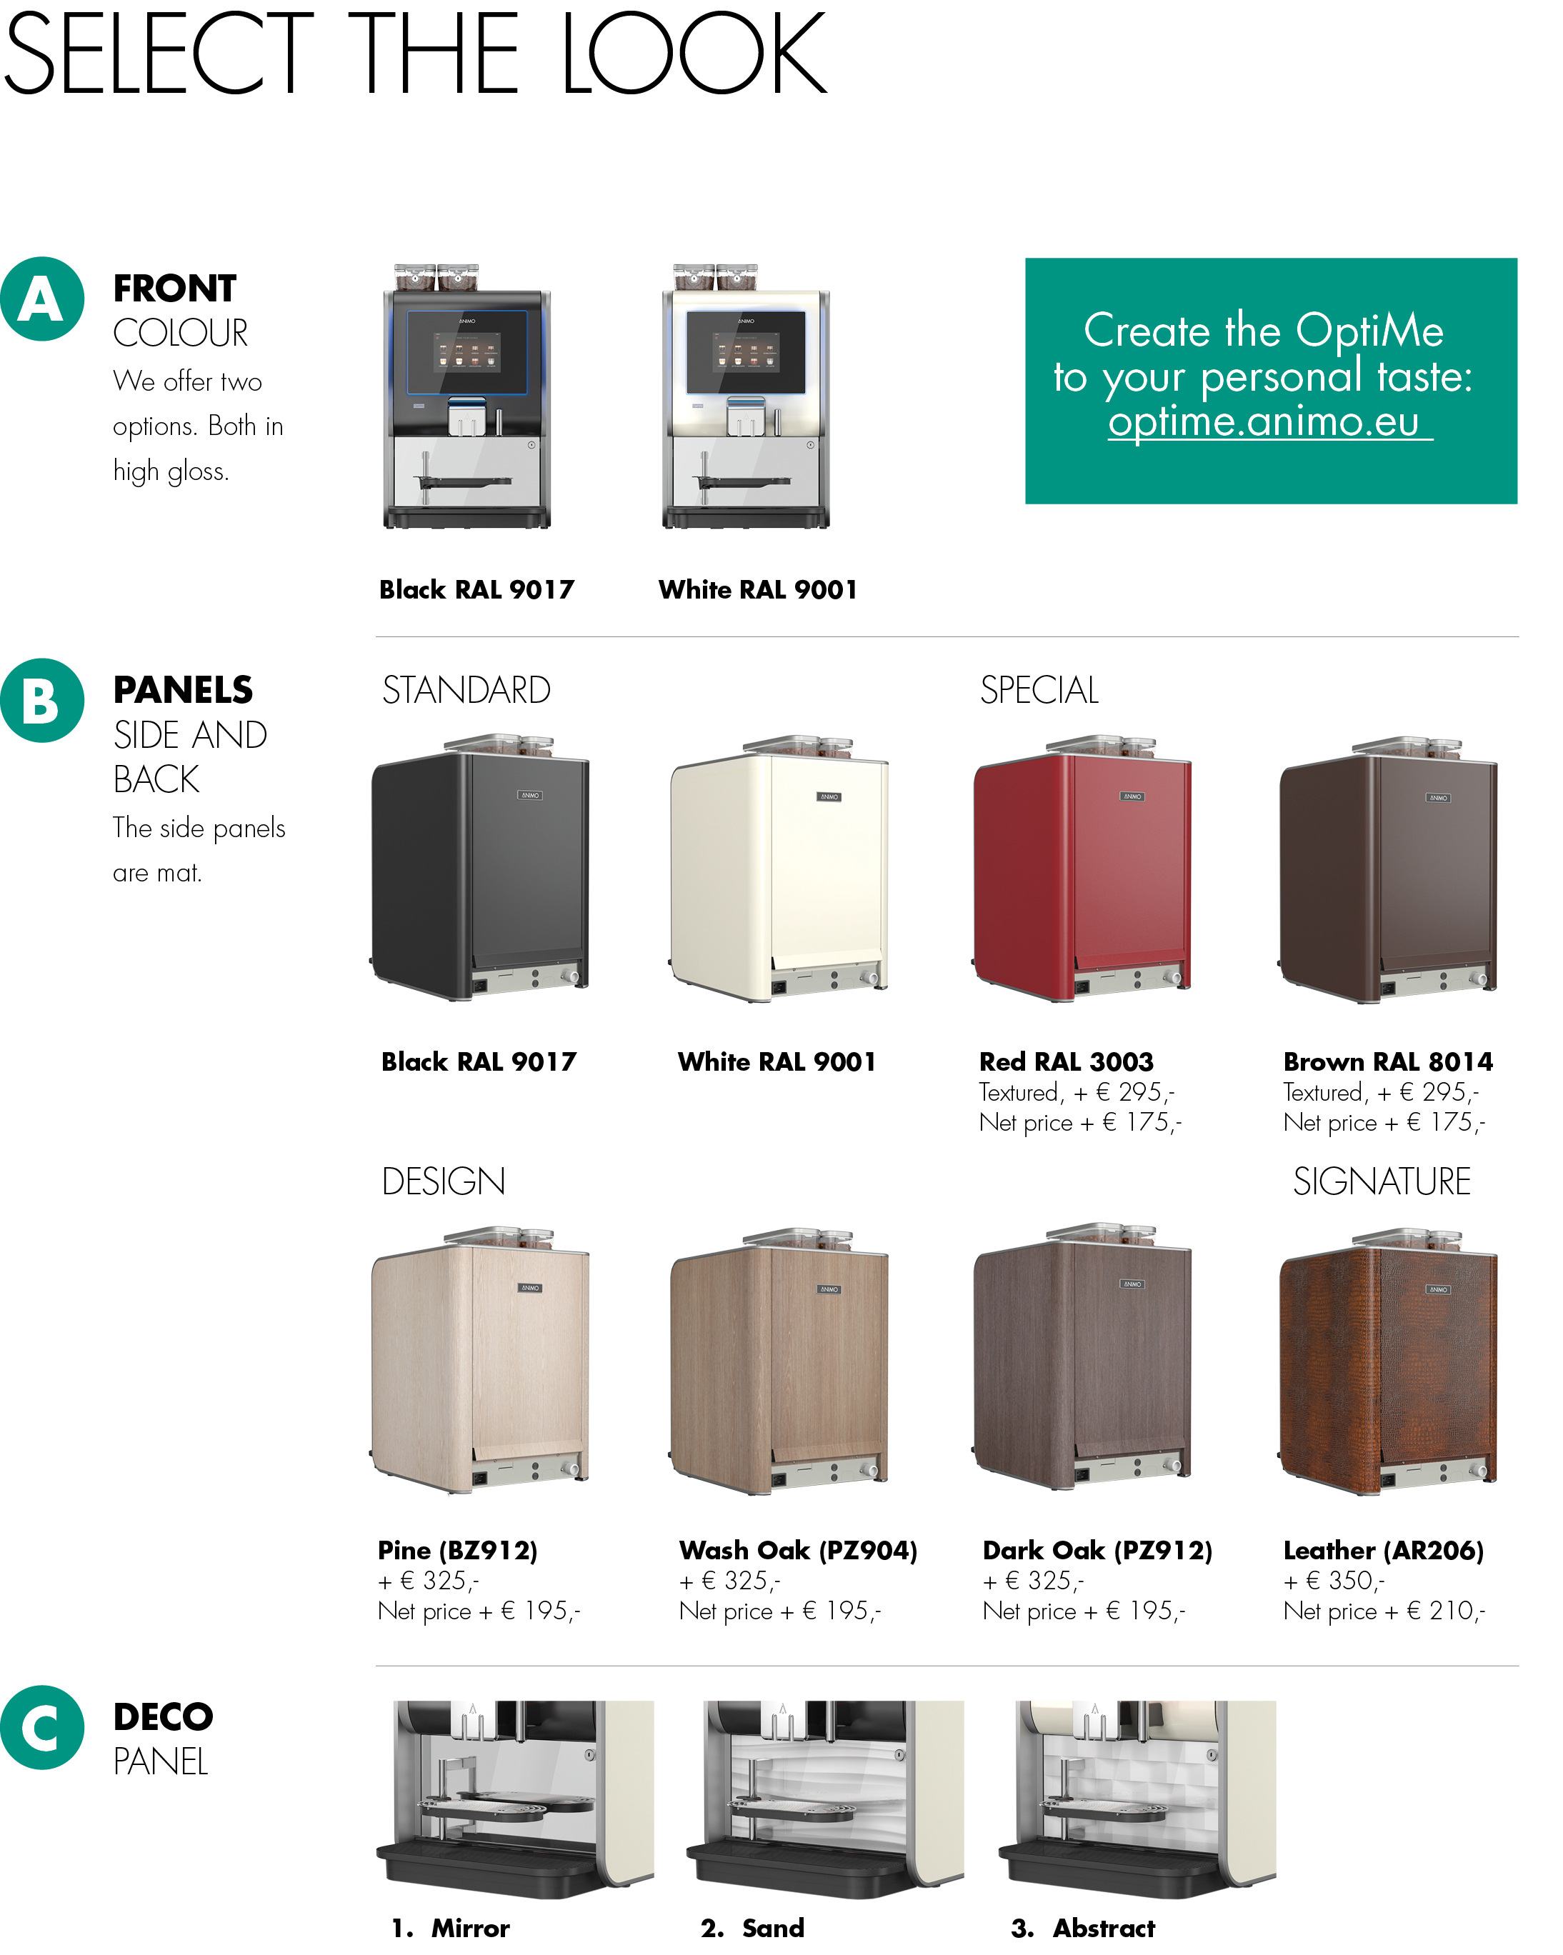
Technical specifications:
Dimensions (w x d x h) : 380x515x600 mm.
Adjustable cup tray : 50 - 105 mm
Max. tap height : : 165 mm
Recommended daily output : up to 125 beverages
Brewing time, cup (120 ml) : 25 – 30 sec.
Capacity espresso brewer : 6,5 - 9,5 gr.
Content boiler : 0,5 l, 1800W
Content bean canister : 1 x 1200 gr. (160 cups)
Content instant canister : 2 x 600 gr. (85cups)
Power supply : 220-240V / 50-60Hz / 2200W
Water connection : 3/4 ”
Art. No. : 1007042 (OptiMe 12)
Gross Price per piece : €

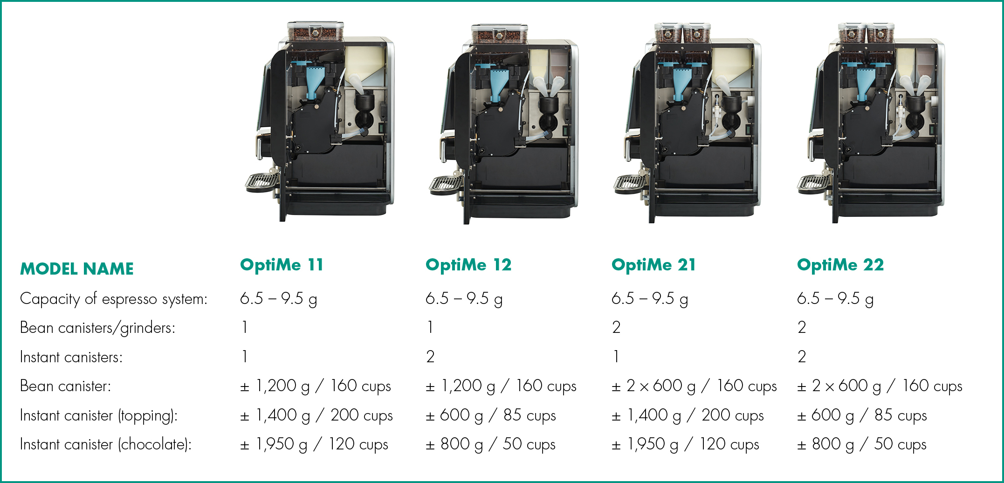

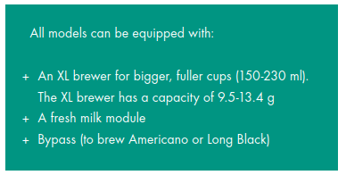

ADD-ONS

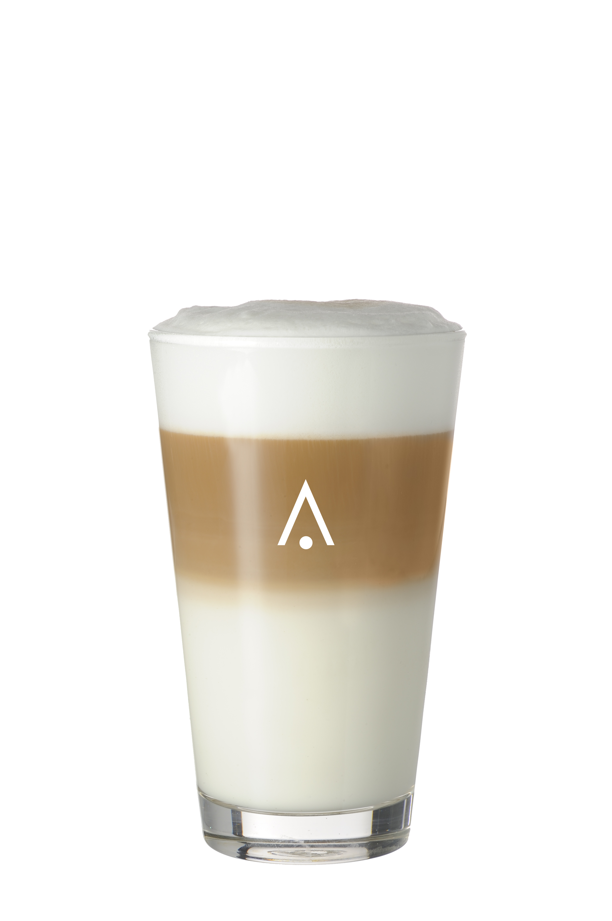
Art. No. 1007181 – Fresh milk module
OptiMe prepared for dispensing drinks with fresh milk. Consists of a steam boiler, milk pump, milk frother and rinsing unit.

+ Silent in use
+ Constant quality
+ Hygiene in accordance with HACCP standards
+ Maintenance friendly with quick and easy cleaning: the user interface perfectly guides you through the cleaning processes

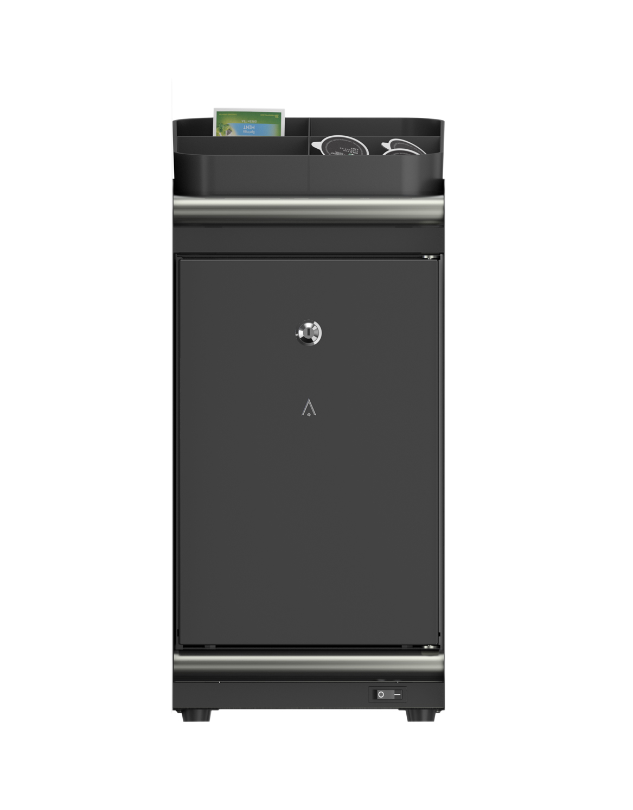
Art. No. 1007180 – Milk cooler
Lockable milk cooler with milk connection on the left side.
Milk tank of 4 ltr. Including ingredient box (1007229) on top.

+ Add-on for all OptiMe models (always on right side)
+ Standard equipped with ingredient tray on top
+ Quick and easy cleaning (according HACCP standards)
+ Combined usage with topping possible
+ Milk pump in coffee machine; constant and perfect barista milk foam
+ Dispensing milk foam and hot or cold milk
+ Capacity milk: 4 l
+ Lockable door

Colour front door : high gloss black
Electrical connection : 220-240V / 50-60Hz / 43W
Dimensions (w x d x h) : 230x420x455 mm.
Colour side/back panel : select in conﬁgurator
Weight : ± 19 kg

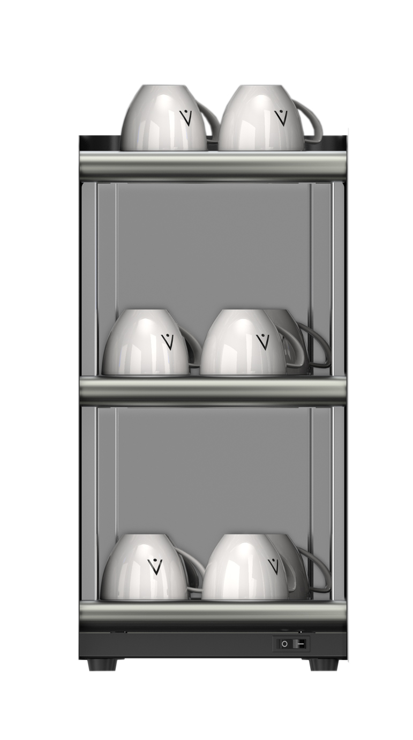
--------------------------------------------------------------------------------------------------------------

Art. No. 1007186 – Cup warmer
+ Add-on for all OptiMe models
+ 3 heated shelf floors

Capacity : abt. 60 coffee cups /
144 espresso cups (stacked)
Electrical connection : 220-240V / 50-60Hz / 105W
Dimensions (w x d x h) : 230x420x455 mm. (without cups)
Colour side/back panel : select in conﬁgurator
Weight : ± 11 kg

