Art. No. 1006005 – OptiFresh 3 Touch black
Art. No. 1006013 – OptiFresh 3 Touch white
Art. No. 1004729 – OptiFresh 3 Touch stainless steel

OPTIFRESH 3 TOUCH: Automatic coffee machine for fresh filtered coffee
The OptiFresh Touch of Animo is simple to operate with easy-to-swipe touchscreen. The OptiFresh Touch can be used anywhere and is the perfect coffee machine for, among others, offices, hotels, restaurants, hospitals, breakfast rooms, care homes, schools and (sports) canteens.

Brew quickly fresh filter coffee, cappuccino or tea, with just one touch. It’s as simple as that.

A modern Fresh Brew coffee machine with permanent stainless steel filter for the preparation of fresh brewed coffee. Execution with 1 canister for Fresh Brew coffee and 2 canisters for instant products. Adjustable coffee strength. Separate hot water outlet. Adjustable mixer speed (rpm) and cup tray, Ideal cleaning program. Large waste compartment for coffee residue with indication.

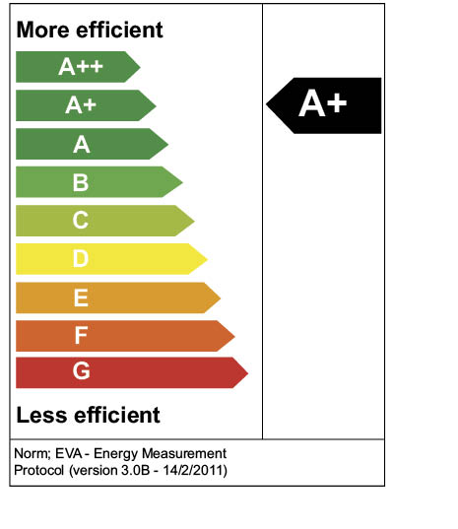
Main advantages of the OptiFresh Touch:
- Most modern design in combination with high quality components
- Simple to use and very easy to clean
- LED / OptiLight lighting can be adjusted to your own preference
- A+ Energy thanks to Energy Save Mode and Insulated stainless steel boiler
- Ideal Screensaver for logo, images, video or advertisement

Specifications:
Dimensions (w x d x h) : 409x575x773 mm.
Adjustable cup tray : 60 - 115 mm
Max. tap height : 167 mm
Hourly capacity : ca. 130 cups (120 ml) / 15 ltr
Brewing time, cup (120 ml) : 28 sec.
Content bean canister : 1800 gr. / 230 cups
Number of fresh brew canisters : 1 x 5,1 ltr
Number of instant canisters : 2 x 2,3 ltr
Power supply : 1N~220-240V / 50-60Hz / 2300W
Water connection : 3/4 ”
Art. No. : 1006005 (black), 1006013 (white), 1004729 (stainless steel)
Gross Price per piece : €

