Art. No. 1006009 – OptiFresh Bean 3 Touch black
Art. No. 1006017 – OptiFresh Bean 3 Touch white
Art. No. 1004733 – OptiFresh Bean 3 Touch stainless steel

OptiFresh Bean 3 Touch: Coffee machine for fresh filtered coffee with beans
The OptiFresh Bean Touch of Animo is simple to operate with easy-to-swipe touchscreen. The OptiFresh Bean Touch can be used anywhere and is the perfect coffee machine for, among others, offices, hotels, restaurants, hospitals, breakfast rooms, care homes, schools and (sports) canteens.

Brew quickly fresh filter coffee, cappuccino or tea, with just one touch. It’s as simple as that.

A modern Fresh Brew coffee machine with permanent stainless steel filter for the preparation of fresh brewed coffee. Execution with 1 bean canister and 2 canisters for instant products. Adjustable coffee strength. Separate hot water outlet. Adjustable mixer speed (rpm) and cup tray, Ideal cleaning program. Large waste compartment for coffee residue with indication.

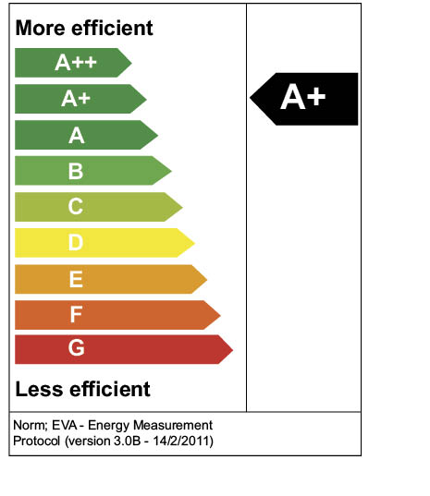
Main advantages of the OptiFresh Bean Touch:
- Most modern design in combination with high quality components
- Simple to use and very easy to clean
- LED / OptiLight lighting can be adjusted to your own preference
- A+ Energy thanks to Energy Save Mode and Insulated stainless steel boiler
- Ideal Screensaver for logo, images, video or advertisement

Specifications:
Dimensions (w x d x h) : 409x575x865 mm.
Adjustable cup tray : 60 - 115 mm
Max. tap height : 167 mm
Hourly capacity : ca. 130 cups (120 ml) / 15 ltr
Brewing time, cup (120 ml) : 28 sec.
Content bean canister : 2200 gr. / 290 cups
Number of instant canisters : 2 x 2,3 ltr
Power supply : 1N~220-240V / 50-60Hz / 2300W
Water connection : 3/4 ”
Art. No. : 1006009 (black), 1006017 (white), 1004733 (stainless steel)
Gross Price per piece : €

