Art. No. 1012320 – OptiMe X 22 black
Art. No. 1012321 – OptiMe X 22 white

OptiMe X
Just the way you like it

With its smart combination of high quality parts and technical skills, OptiMe X produces freshly ground coffee and many variations in no time. Equipped with the high quality X-press brewer, OptiMe X is the ultimate upgrade for your coffee.
+ Swiss made X-press brewer: 6 - 20 gr / 25 - 350 ml
+ One or two coffee grinders
+ Top quality coffee
+ Dispense bigger cups
+ Brew two cups at once

Animo’s OptiMe X is suitable for about 40 to 125 cups of coffee per day and therefore making it suitable for locations with around 35 people. The machine can be used and placed everywhere.

+ Compact 360 design
+ Front in black or white
+ Side panels in black or white
+ Inviting and user friendly interface
+ OptiLight LED lighting (any colour, RGB)
+ Beans are visible for the authentic espresso experience
+ Consistent in-cup quality
+ Adjustable tamping pressure and extraction time
+ Up to 24 programmable recipes
+ Strength control for coffee, milk and sugar

Technical specifications:
Dimensions (w x d x h) : 380x515x600 mm.
Adjustable cup tray : 50 - 105 mm
Max. tap height : 165 mm
Brewing time, cup (120 ml) : 25 – 30 sec.
X-press brewer capacity : 6 – 20 gr. / 25 – 350 ml
By Pass : Standard with bypass option
Capacity bean hopper : 2 x 600 gr / 160 cups
Hourly capacity : 60 cups (single brew), 120 cups (double brew)
Waste compartment : 550 gr - 80 pucks
Power supply : 220-240V / 50-60Hz / 1950W
Number of bean hoppers/grinders : 2 x 600 gr.
Number of instant canisters : 2 (1 ltr)
Content canister 1 : Cacao 800 gr. / 50 cups
Content canister 2 : Topping 600 gr. / 85 cups

Net Price per Unit : €
Quantity :

Standard all black Standard all white
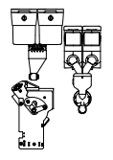
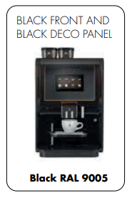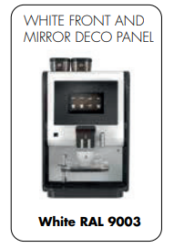

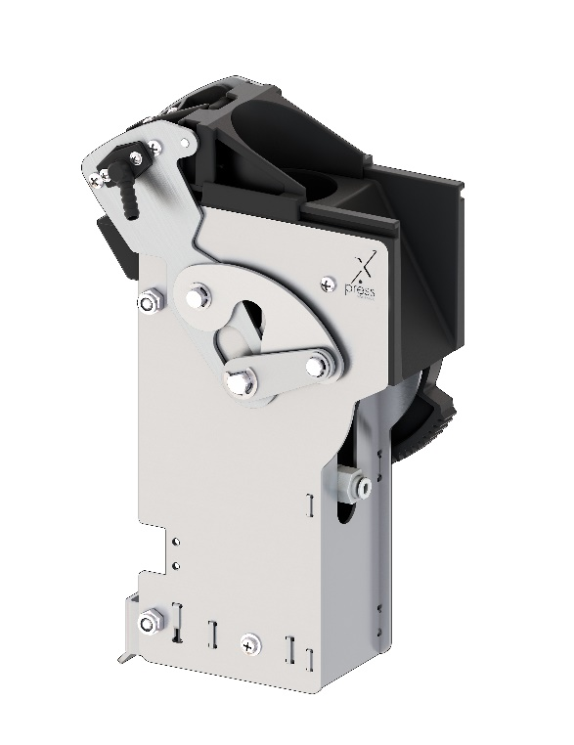
Other colour combinations than standard

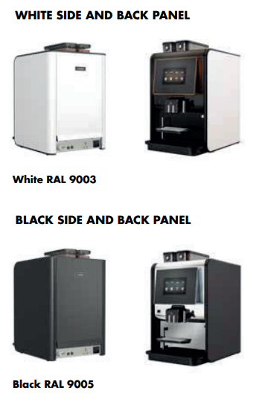
Art. no. 1012341
Art. no. 1012342

Other deco panel than standard

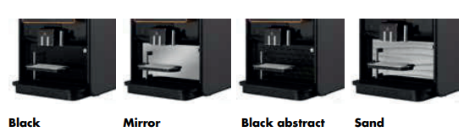
Art. no. 1012346
Art. no. 1012344
Art. no. 1012345
Art. no. 1012343

